# Chapter 1 Computational Problem Solving

1. What are the types of computational problems? Define and give one example *****

Decision problem: A decision problem has only two possible outputs.

E.g. yes or no (or alternately 1 or 0) on any input. "Given a positive integer *n*, determine if *n* is prime." primality testing can be represented as the infinite set: *L* = {2, 3, 5, 7, 11, ...}

Search problem: given an instance find a solution.

*E.g. object satisfying certain properties. Factoring can be represented as the relation: R = {(4, 2), (6, 2), (6, 3), (8, 2), (9, 3), (10, 2), (10, 5) ...} which consist of all pairs of numbers (n, p), where p is a nontrivial prime factor of n.*

Optimization problem: given an instance find a best solution according to some cost criterion.

*E.g.  the maximum independent set problem: "Given a graph G, find an independent set of G of maximum size."*

Counting problem: given an instance count the number of solutions.

*E.g. a counting problem associated with factoring is: "Given a positive integer n, count the number of nontrivial prime factors of n."*

1. Greedy Algorithm

A greedy algorithm finds the best solution to a problem one step at a time. At each step, the algorithm makes the choice that improves the solution the most, even if that choice makes future steps less fruitful. Sometimes this gives you the right answer to the problem, but a lot of times you can't solve stuff this way. An algorithm that makes the locally optimal choice at each stage with the hope of finding a global optimum. Short term visionary instead of long term.

1. Simulated Annealing Algorithm

Simulated Annealing (SA) is a viable and general type of improvement. It is valuable in finding worldwide optima within the sight of huge quantities of neighborhood optima. However, this algorithm generates very high heat for the CPU, and it takes several times as long to find a solution for 2OPT. Although it is possible that the results obtained by this method are optimal, it is not practical.

1. Artificial bee colony (ABC)

Artificial Bee Colony is one of the most recently defined algorithms by Dervis Karaboga in 2005, motivated by the intelligent behavior of honey bees. ABC as an optimization tool provides a population – based search procedure in which individuals called food positions are modified by the artificial bees with time and the bee’s aim is to discover the places of food sources with high nectar amount and finally the one with the highest nectar.

1. **Engineering change orders** (**ECO**)

ECO are used for changes in components, assemblies, or documents such as processes and work instructions. They may also be used for changes in specifications. Lastly, it can be "a modification that will have an effect on a manufactured product or manufacturing process.

# Chapter 2 machine learning

1. Examples of control theory in machine learning are ‘fuzzy logic’. Describe fuzzy logic and provide a suitable example. (5 Marks)

Fuzzy logic: is much more general than traditional logical systems. The greater generality of fuzzy logic is needed to deal with complex problems in the realms of search, question-answering decision and control. It does propositions that can be represented with degrees of truthfulness and falsehood. For example, the statement, today is sunny, might be 100% true if there are no clouds, 80% true if there are a few clouds, 50% true if it's hazy and 0% true if it rains all day.

1. Discuss the difference between Supervised and Unsupervised learning with appropriate examples.

Supervised learning: Training information (observations, measurements, etc.) are followed by labels showing the observations class. Based on the training set, new information are categorized. For instance: Filtering a fresh incoming email into Inbox (ordinary) or Junk folder (Spam) based on previous spam data.

Unsupervised learning: The training data class labels are unknown. Due to a set of measurements, observations, etc. In order to determine the presence of classes or clusters in the information. For instance: Join a party that is completely strange. This person classification can be based on sex, age, dressing, academic qualification or whatever you want.

A form of reinforcement learning can be used for unsupervised learning, where the agent bases its actions on the previous rewards and punishments without necessarily even learning any information about the exact ways that its actions affect the world.

1. Example of machine learning problems:

* **Optical character recognition:** categorize images of handwritten characters by the letter represented (classification)
* **Face detection:** find faces in images (or indicate if a face is present)
* **Spam filtering:** identify email messages as spam or non-spam
* **Topic spotting:** categorize news articles - Politics, sport, entertainment, etc. (clustering)
* **Spoken language understanding:** within the context of limited domain, determine the meaning of something uttered by a speaker to the extent that it can be classified into one of a fixed set of categories
* **Predict house prices** – Size, location, etc. – Regression

1. Define Inductive Learning.

Inductive learning is a process of finding a hypothesis that agrees with the observed examples.

# Chapter 3 introduction to robotics

1. Describe THREE (3) types of robot in AI study.

**Stationary robots:** Stay in one place all the time. Control programs are stored on disc or tape. Can be *reprogrammed* to do a different task. Examples are welding robots, CNC plate cutters or CNC drills.

**Mobile Robots**: Robots which move are called *mobile* robots. They use tracks, wheels or legs to move. Good for getting to places that humans can’t, for example the Mars robot. E.g. Aerial robots, also known as unmanned aerial vehicles (UAVs) or drones, which fly through the air.

**Humanoid Robots**: built to resemble that of the human body. Simulation of the human body leads to a better understanding of it. How humans learn from sensory information in order to acquire perceptual and motor skills. E.g. Ursula, a female robot, sings, plays music, dances and speaks to her audiences at Universal Studios

1. Describe the following robot manipulator: Open loop chain and Close loop chain.

Open-loop control system: Does not use sensory feedback to determine the outcome of their actions.

Closed-loop feedback control system: Uses sensory feedback from test effects to help measure subsequent outputs of the controller.

1. New View of perception in robots
2. Action-oriented perception: sensory processing adapted to meet the needs of motor movements.
3. Expectation-based perception: World knowledge can limit the interpretation of what is present in the world.
4. Focus-of-attention methods: Knowledge may limit where things in the world can appear.
5. Active perception: Using sensor orientation, the agent can use motor control to enhance perceptual processing.
6. Perceptual classes: Divide the world into different potential types of communication.

# Chapter 4 Simulation and Modeling

Real system simulation

* Experimentation on “the real system” can be done in concept, but often cannot be done in practice.
* Experimenting on the real system requires of course that the system exists, and it might not (the goal might in fact be to design a system)
* If the system does exist, it might not be feasible to experiment with it, for reasons such as these:
  + Economic reasons: it might be prohibitively expensive to interrupt the ongoing use of the real system
  + Political reasons: it might be difficult to get permission from the system’s “owners” to experiment with the system)
  + Real-system experiments might take too long: Time taken by real system experimentation can be days, weeks, or months of experimentation might be required, and so the findings might not be available in time to do any good.

Chapter 5 introduction to Natural Language Processing (NLP)

1. Describe each of the following NLP categories:-

**Syntactic analysis （语法分析）**

A grammar checker which explains how words are put together in a sentence and linked to each other. In programming syntax, the linear sequence of the individual word and punctuation mark in NL is usually transformed into a hierarchical tree (parse tree) such as tagging, chunking / detecting syntactic categories (verb, nouns, phrase, etc.) and the syntax is constructed.

**Semantic analysis （逻辑分析）**

It is assigning meanings to syntactic analyzed structures. Mapping words and structures in a manner consistent with our knowledge of the world to specific domain objects.

**Pragmatic analysis（表达不完整，有下句没上句）**

Studying the meaning of the word / sentence. Lots of word spelling is the same in human life, sometimes similar, but content's meaning is different. It is the situational study of the use of words. This discusses how individuals in a real-world situation understand and establish communicative behavior.

1. What is ‘lemma’ and ‘stem’ in NLP? 🡪**Morphological Analysis:** **It is a subdiscipline of linguistic that study word structure**

Lemmatization: means doing things properly using a vocabulary and morphological analysis of words, returning the basic or dictionary form of a word known as lemma. For example: mom, mummy -> mother.

Stemming: primitive heuristic method of chopping off the ends of words in the hope of correctly achieving the object of meaning. For example: walked, walks, walking--> walk

1. Why it is important to study NLP? Justify your answer.

The processing of natural language (NLP) is an artificial intelligence branch that helps computers understand, interpret and manipulate human language. It helps computers in their own language communicate with people and scales other language-related tasks. It also helps to overcome language uncertainty and provides valuable statistical structure to the information for many downstream applications, such as speech recognition and text processing.

1. Parsing sentences (parse tree)

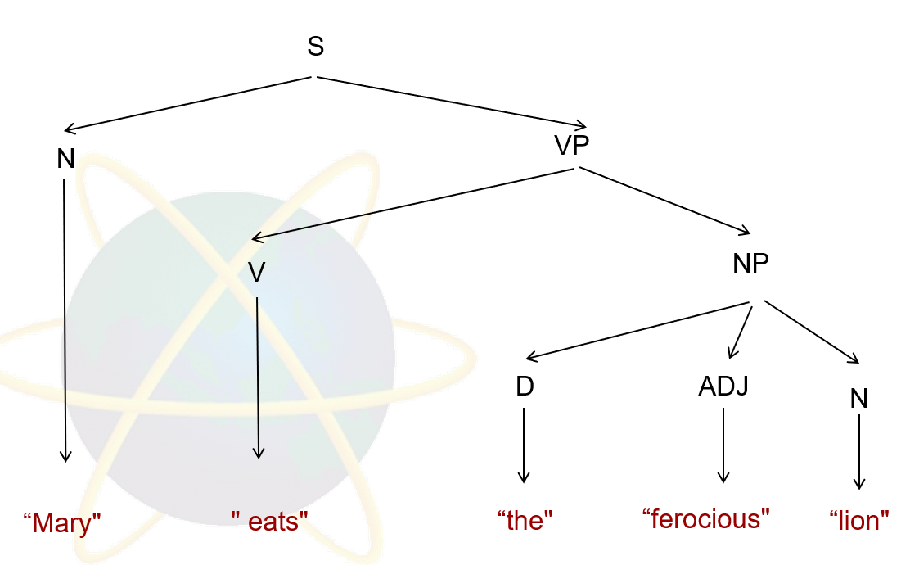

# Chapter 5 Swarm Intelligence, technique and application

1. **Describe the concept of stigmergy in your own words.**

Stigmergy is a term used in biology to describe environmental mechanisms for coordinating the work of independent actors.

E.g. ants use pheromones to create trails and people use weblog links to establish information paths, for others to follow.

1. **Swarm and agents**

**Swarm** is the collective behavior of decentralized, self-organized systems, natural or artificial. The concept is employed in work on artificial intelligence.

E.g. group foraging of social insects; cooperative transportation; division of labour; nest-building of social insects; collective sorting and clustering

**Intelligent agent (IA)** refers to an autonomous entity which acts, directing its activity towards achieving goals, upon an environment using observation through sensors and consequent actuators.

E.g. perceiving its environment through sensors and acting upon that environment through actuators

1. **Ant foraging**

Organizing highways to and from their foraging sites by leaving pheromone trails. Form chains from their own bodies to create a bridge to pull and hold leaf together with silk

1. **Self-organization**

Self-organization can be defined as a set of dynamical mechanisms that establish basic rules for interactions between the components of the system.

1. 4 bases of self-organization

**Positive feedback**: As the nectar amount of food sources increases, the number of onlookers visiting them increases, too. (amplification)

**Negative feedback:** The exploitation process of poor food sources is stopped by bees. (for counter-balance and stabilization)

**Fluctuations:** The scouts carry out a random search process for discovering new food sources. (randomness, errors, random walks)

**Multiple interactions:** Bees share their information about food sources with their nest mates on the dance area.

# Chapter 6 Artificial Immune System and algorithm

**Application of AIS**

1. Discuss THREE (3) areas where Artificial Immune Systems can be used.

a. Anomaly Detection -The normal behavior of a system is often characterized by a series of observations over time. The problem of detecting novelties, or anomalies, can be viewed as finding deviations of a characteristic property in the system. For computer scientists, the identification of computational viruses and network intrusions is considered one of the most important anomaly detection tasks

b. Network Security - an artificial immune system is distributed, robust, dynamic, diverse and adaptive, with applications to computer network security.

c. Bridge Fault detection – A bridge is analogous to the Human Body. Vibrations caused in the bridge are antigens. Self-Set contains safe patterns (e.g. cars, trucks etc.). Detector-Set (B-Cell) contains unsafe/dangerous vibrations (e.g. very heavy trailers, earthquake, etc.).

1. Explain the role of the Immune System

The immune system protects our bodies from infection by launching a primary immune response to invading pathogens. This removes the threat/pathogens from the body and keeps us healthy. A secondary immune response is then developed, where the immune system remembers past encounters and can provide a faster response the second time around.

1. One example of an application of Artificial Immune Systems in industry.

E.g. Wastewater treatment

1. AIS Algorithms

* Negative selection
* Clonal Selection
* Artificial immune networks (AINs)
* Danger theory

1. How is AIS applied in Bridge Fault Detection?

Bridge is analogous to the Human Body. Vibrations caused in the bridge are antigens. Self-Set contains safe patterns (e.g. cars, trucks etc). Detector-Set (B-Cell) contains unsafe/dangerous vibrations (e.g. very heavy trailers, earthquake, etc).

1. How can AIS solve problems in Computer Security?

The computer viruses as antigens which contains the bytes of the head of a file, the file size and path. The detectors as B-, T-cells and antibodies which detects the first few bytes of the head of a file, the file size and path in the form of proteins, known as the string in computer systems, then antibody or antigen binding to do pattern matching with self-information. Subsequently, the viruses are neutralized by overwriting the self-information on the infected files.

1. How is AIS applied in **Data Mining**?

Movie Recommender System. Server is the Human Body. Incoming requests are the antigens.

Encoding is: User = ({id1,score1},....,{idn,scoren}). Selection of Similarity Measure (correlation). Create clusters based on the correlation measure. AIS keeps on growing progressively by putting the new user into the relevant clusters. Person interested in entertainment may also be interested in (say) cricket.

1. Describe the concept of Artificial Immune Systems.

Our body’s immune system is a perfect example of a learning system. It is able to distinguish between good cells and potentially harmful ones (Antigens). Artificial Immune Systems (AISs) are learning and problem solvers based on our own immune systems.